Dommere for dobbelutstilling 7-8 september 2013 !
Drammen travbane

Stefan Sinko, Slovenia
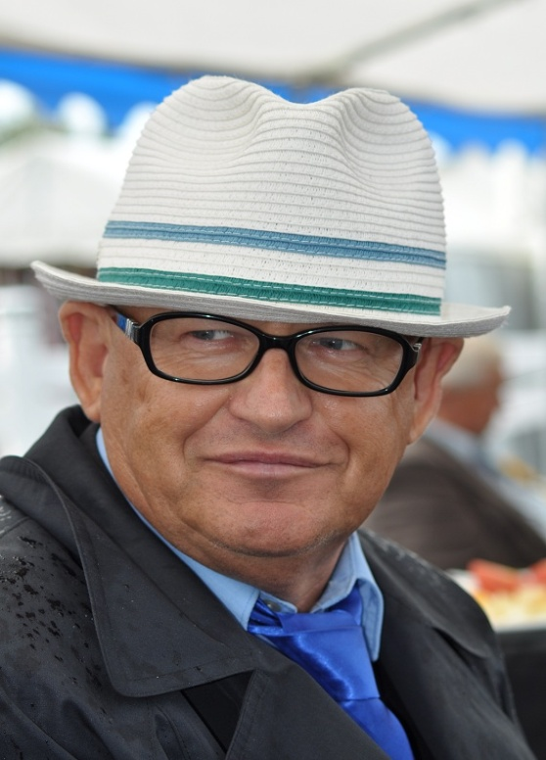
FCI all breeds judge, regularly invited to all parts of the world. Mr Sinko started breeding and showing Bulldogs in 1979 and established the Jubilee Bulldog kennel. He has raised many national and international champions including FCI, European, and world winner Bulldogs. He has owned: Great Danes, Airedale Terriers, Basset Hounds, Dogo Argentine. Mr Sinko has judged at championship show level since 1986 on all continents, in total in 65 countries. He has judged prestigious shows including FCI European and World shows. In 2004 he judged Bulldogs at Crufts with a total entry of 210 exhibits, and has judged at the Brisbane Royal, and in Sydney, Melbourne and Adelaide. From 1992 until 1997 he was the first democratically elected President of the Slovenian Kennel Club, foundation president of the Slovenian Molosser and big sized Breeds Club and the Slovenian Terrier Club. In the FCI from 1994 until 1996 he was vice president of the FCI judges committee, and at present is honorary president of several clubs.

Joao Pocas, Portugal
Breeder of Pyrenean Mountain Dog since 1987. Owner also of Boxer and Saint Bernard. Kennel name Domaine de L'Ètoile. Breeds name in association "Neouvielle". Owner and breeder of several champions. Vice President of the Portuguese Newfoundland Club, Vice President of the Portuguese Great Dane Club and Vice President of the Portuguese Saint Bernard Club. FCI International judge since 1996. Judged in Portugal, Spain, Germany, Yugoslavia, Belgium, Norway, Great Britain, Slovenia, France, Denmark, Sweden and Italy.

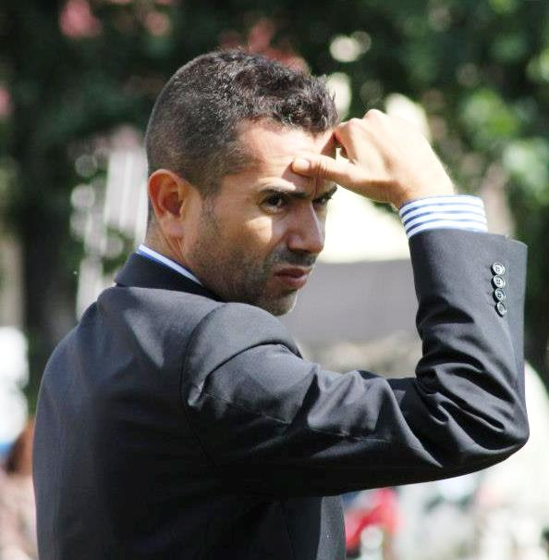
Tony moran, irland
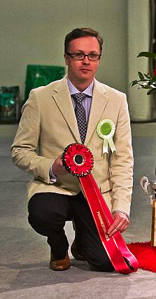
Tony Moran was born 17th March 1967. He got his first dog at the age of 7 years - a Pembroke Welsh Corgi. This was followed later by a Pyrenees Mountain Dog in 1978. This was to be the first dog to be shown. In 1981, the first Tibetan Spaniel made an appearance Crookfields Too Pi Jai. He was an English import and was joined in early 1984 by Amichiri Chang Tru. This pair were to be the nucleus of the foundation at the Avigdor Tibetan Spaniel Kennel. The first litter was born in September 1985 and produced two Champions, Irish Champion Avigdor Sophia and Irish Champion Avigdor Sebastian. The rest is history. His success at Breed Championship shows is unsurpassed. To date he has won 15 Best in Shows and 12 Res Best in Shows. No other kennel in Ireland can claim this level of achievement. They also have won many top awards under knowledgeable breed specialists. His best-known Tibbie is probably GB & IR CH. Avigdor Jarrod. In 2003 Chihuahua's joined Avigdor, and in 2005 Griffon Belge were added, plus Tony co-owns a Japanese Chin. In 2007, the first Belge litter was born, under the Castafiore affix and they kept a male Belge and a black Petit Brabancon female. Vincent has judged many Specialty Shows around the world and is a popular judge. Appointments in 2009 included Sweden, Czech Republic, France, Germany, Finland and the UK.

Antonio di Lorenzo, norge
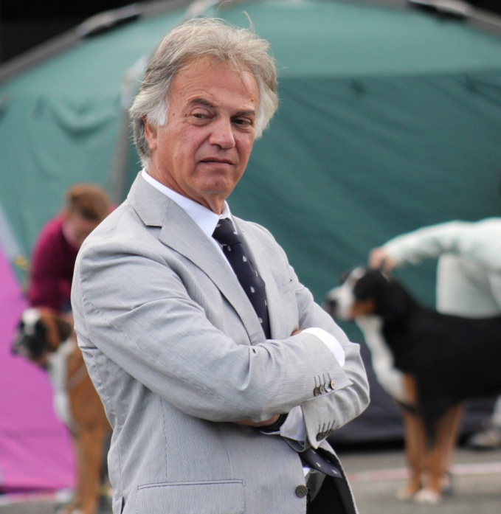
Antonio was really young when he started breeding Neapolitan Mastiffs; he now has 37 years experience in the breed. Many dogs from his kennel were Champions: an example, "Ramona dell' Altafiumara", winner also in Naples, and her son, the famous "El Gavilan dell' Altafiumara", who won the World Championship twice. Antonio started with the Neapolitan Mastiffs and then he extended to other breeds, especially those morphologically similar to the Mastiffs. He has held several seminars of breeds in Italy, Israel, Mexico, Russia, USA, England and has judged all over the world. Antonio is still breeding and showing Mastino Napoletano, and now he has been living in Norway the last 3 years.

Nemanja jovanovic, Serbia
Nemanja is a breeder of West Highland White Terriers, Scottish Terriers, and Jack Russell Terriers and the owner of several International and European Champions. He is the former President of the Yugoslav Youth Kennel Club and the current President of the Veterinary Faculty of Cynology which organizes seminars for apprentice judges. He has judged all over Europe and Scandinavia and Russia and is a Best in Show judge as well as a FCI judge for the following groups: 2, 3, 4, 5, 8 and 9.

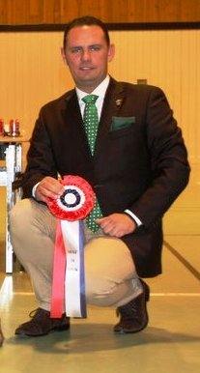
Lorena merati, italia
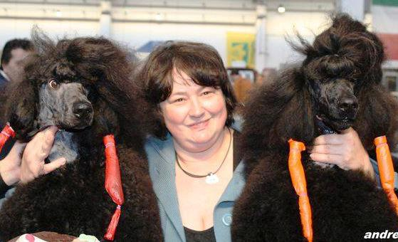
I have my kennel name Samarcanda since 1983 in Italy. Samarcanda is the name of a beautiful Italian song of the 70's , talking about an old legend, of a horse , orses being my second love .
I had my first poodle (a black miniature) when I was 13, and my first standard I was 18, with this dog I imported from Germany I won a lot in Italy and abroad. When I met my husband I started show and breed Airedale terriers ,what we still do now. Few people they know that in the past I bred some litters of Neapolitan Mastiffs and smooth fox terrier making many champions.
In my home I have 15 standard poodles from one year up to eleven, 3 boys an 12 girls , in black, white , brown and silver. From many years I groom and show my dogs by myself, being a professional groomer, and international judge of grooming competition, but during the time many friends that are groomers too, having my poodles, help me keeping them in condition and bathing and grooming their dogs before the shows. Being a judge from few year, because I spent all my life showing, I am very proud because in a short time I collected several invitations from many European country and from USA
Martin croeser, sør afrika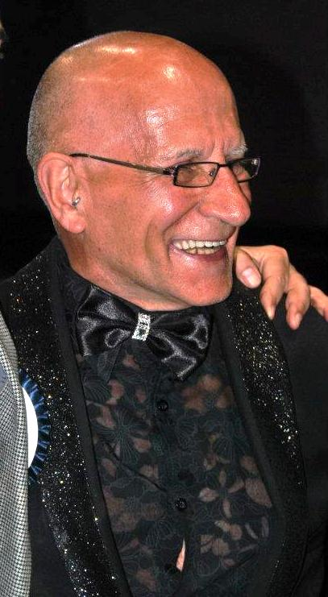
Martin, a well-respected international judge, inherited his love for animals from his late father who had Smooth Fox Terriers. He was given his first show dog in 1968, an Afghan with the most terrible temperament. He was involved with Whippets for many years, breeding and showing very successfully. At the same time he was given three Saluki which became his main breed for 25 years. He also added Standard Poodles and Dobermann's to his kennel. Martin has been judging since the early 1970's and became an All Breeds judge in 1984. He started his international judging career in Helsinki in 1993, followed by Switzerland, Brazil, Moscow, Indonesia, India, Malaysia, Norway, Finland, Germany, Italy, Sweden, Poland, Namibia, Zimbabwe, Australia, New Zealand (Auckland), the Netherlands and Perth Royal Show, Australia in 2009.

Kitty sjong, danmark
In November 2004 the board of the Danish Kennel Klub honoured Kitty with the Gold Honour for her prominent breeding of Papillons and Phalenes, since she got her first Papillon in 1977 as a present. In addition to the little lively Papillons the family have also had Belgian Tervueren. She has made up 38 Champions under the prefix Inkie and has had great success in the show ring in Denmark and America. She handled Am Ch.Inkies Keepsake Katie to Winners Bitch and Best of Winners at an Independent Papillon Club of America Specialty, the first Phalene to achieve this award. Kitty is a member of the board of the Danish Kennel Klub's District 1, Chairman of the Danish Papillon Club and is approved to judge breeds in FCI Groups 1, 2, 3 and 9. Judged at the International Spring Fair in Sydney 2010.

